Presentation by
Stu Dent (Name)

Presentation for

AIT, Cert II IT

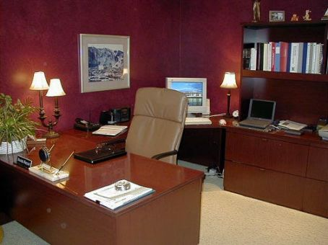

Equipping an Office

Date SSubmitted: date Number of Words: 2, 865

Signature: I Stu Dent advise that this work submitted is my own work and has not been copied or reproduced without reference to the appropriate author.

Table of Contents

- Computer System Page 3

1.1 Hardware specifications Page 3
1.2 Software Page 5
1.3 Prices Page 6

- Infrastructure Page 6

  - Workstation Page 6
Network configurations Page 8
Client communication (Including workers on the move) Page 9

- Security Page 9

Physical security Page 9
  - Data security Page 9
Malicious security Page 10

- Training Page 10

4.1 Job description of both office staff and agents – skills for ICT Page 10
Training of both and Salary range of both Page 12

- Bibliography Page 14

- Computer System

  - Hardware specifications

- Computer: Dell Vostro 230s Slim Tower (T220601AU)
Replace with up to date equipment

PART | SPECIFICATIONS
Processor (CPU) | Intel(R) Core(TM)2 Duo Processor E7500 (2.93GHz, 1066MHz FSB, 3MB L2 cache)
Operating System (OS) | Microsoft(R) Office Home and Business 2010 (English)
Security Software | Trend Micro(TM)Internet Security , 15 Months (English)
Monitor | Dell (TM) 23 " E2310H Wide Screen Flat Panel LCD Monitor
Memory (RAM) | 2GB(2X1GB) NECC Dual Channel DDR3 1333MHz SDRAM Memory
Hard Drive (HDD) | 320GB SATA 3.0Gb/s Hard Drive with Native Command Queuing
Optical Drive | 16X DVD+/-RW drive
Video Card | Integrated 5.1 Channel (Audio) Capable
Dell DataSafe Online Backup | Dell Online Backup 2GB
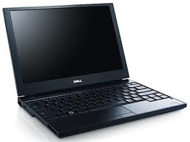
Laptop:

Replace with up to date equipment
PART | SPECIFICATIONS
Processor (CPU) | Intel® Core™ 2 Duo P8700 with VT (2.53GHz, 3M L2 Cache, 1066MHz FSB)
Operating System (OS) | Microsoft(R) Office Home and Business 2010 (English)
Security Software | Trend Micro Internet Security 15 Month - English
Monitor | 17 inch Wide Screen WXGA Anti-glare LED Panel
Memory (RAM) | 4.0GB, DDR2-800 SDRAM, 2 DIMMS
Hard Drive (HDD) | 250GB Hard Drive, 5400RPM
Optical Drive | 8X DVD+/-RW w/Roxio and Cyberlink PowerDVD™, no media
Connectivity | Dell Wireless® 370 Bluetooth Module
Battery | 90W A/C Adapter (3-pin)
Warranty | 1 Year Basic Limited Warranty and 1 Year NBD On-Site Service

EQUIPMENT | FEATURES
Hewlett Packard (HP) Officejet Pro 8500 Wireless Multifunction | - Network Up To 10 Users  - Sided Print  - 3.45" Touch-screen LCD  - 34 PPM Colour / 35 PPM Black  - 4800 x 1200 Print DPI  - 2400 x 4800 Scan DPI  - 250 Sheet Capacity  - 50 Sheet ADF  - Fax Modem 33.6Kbps  - Water resistant documents  - Scan to PC/Email/Network folders or Memory card  - Dimensions: 494W x 479D x 331H mm; 12.7kg  - 1 Year warranty

  - Software

  - Prices

- Infrastructure

  - Workstation
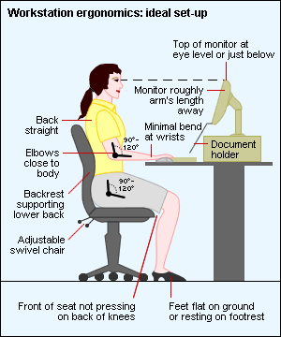
- Your Chair:
- Your Keyboard:

- Screen, Document, and Telephone

- Pauses and Breaks:
- Based on Ergonomics these items would best be equipped for a workstation:
Replace and complete
EQUIPMENT | FEATURES | PRICE
Chair | - Function: Gas Lift, Back Tilt, Back Height, Seat Tilt.  - Weight Limit: 100kg.  - 12 Month Warranty.  - Upholstered in quality fabric.  - Manual back rest and armrest height adjustment.  - Extra thick seat and back rest padding for maximum comfort.  - Available in black, blue or grey.  - Seat Height: 450-560mm.  - Seat Thickness: 78mm.  - Overall Height: 990-1100mm.  - This chair comes flat packed, ready to assemble | $ 69.00 each
Receptionist Desk | - Stylish floating top  - Filing drawer, stationery drawer and notepad space.  - PC Storage with attractive frosted glass door.  - Available in Chocolate finish  - 1500 W x 735 D x 720mm h  - 5 year warranty | $ 139.00 each
Computer Desk | - Finished in charcoal with high grade scratch resistant graphite melamine desktop  - Stationery drawers plus full length filing drawer and storage cupboard  - Thick 25mm top for added strength  - Suitable for use with Merge Corner Hutch  - Flat Packed  - Size: 1500 x 1500 x 720mm  - Warranty: 12 Months | $ 169.00 each

Network configurations

Client communication (Including workers on the move)

- Security

Physical security

  - Data security

Malicious security

- Training

  - Job description of both office staff and agents
- Agents:

- Secretary:

- Computer Technician:

Training of both and Salary range of both
- Training:

- Secretary:

- Computer Technician:

- Salary:
- Agents: per year
- Secretary per year
- Computer Technician: per year

- Bibliography
Date accessed | Title | Web Address | Author | Publication/last modified
24/7 | Dell | www.dell.com.au | - | -
26/7 | Ergonomics in Australia | http://www.ergonomics.com.au/pages/400_useful_info.htm | Digital Creative | -
28/7 | Officeworks | www.officeworks.com.au/ | Officeworks Superstores | 2008
30/7 | About.com: Wireless/Networking | http://compnetworking.about.com/cs/lanvlanwan/g/bldef_wan.htm | Bradley Mitchell | -
30/7 | Wide area network | http://en.wikipedia.org/wiki/Wide_area_network | Wikipedia | 15 June 2010
1/8 | What is physical security? | http://searchsecurity.techtarget.com/sDefinition/0,,sid14_gci1150976,00.html | - | 15 Dec 2005
1/8 | Physical security | http://en.wikipedia.org/wiki/Physical_security | Wikipedia | 26 July 2010
1/8 | Spam Laws: What is data security? | http://www.spamlaws.com/data-security.html | Spam Laws | 2009
1/8 | Malware | http://en.wikipedia.org/wiki/Malware | Wikipedia | 29 July 2010
3/8 | My Career | http://mycareer.com.au/jobs/ | - | -

